**Class 10th**

**Q1.**

**Question Type: MCQ**

**Question Difficulty Level: Medium**

**Marking: (+2, -0.5)**

**Expected time to solve: 30 seconds**

**Topic: Advance Math**

**Concept: Algebra**

**Sub- Concept: Quadratic equation**

**Concept Field:**

If one root of the quadratic equation is , then find the value of k for the given quadratic equation? `

1. Rs.244
2. Rs.251
3. Rs.160
4. Rs.145

**Answer:** c

**Solution:**

Since x=2 is a root of the equation

**Q2.**

**Question Type: MCQ**

**Question Difficulty Level: Medium**

**Marking: (+2, -0.5)**

**Expected time to solve: 30 seconds**

**Topic: Basic Math**

**Concept: number system**

**Sub- Concept: HCF and LCM of number**

**Concept Field:**

Find the HCF of 144 and 1024 by prime factorisation method. Hence, find the LCM of the given number?

1. 16, 9216
2. 17, 2284
3. 24, 3853
4. 56, 2884

**Answer: B**

**Solution:**

We know that,

and

To find HCF of given number we opt out common prime factors and their smallest exponents in 144 and 1024 as under

Common prime factor is 2 and its least exponent is 4

So, its HCF

To find the LCM of given number we opt out all prime factor of 144 and 1024 and their greatest exponents.

Prime factor of 144 and 1024 is 2 and 3

Their greatest exponent=

So

**Q3.**

**Question Type: MCQ**

**Question Difficulty Level: Medium**

**Marking: (+2, -0.5)**

**Expected time to solve: 30 seconds**

**Topic: Basic Math**

**Concept: Algebra**

**Sub- Concept: Types of Algebraic expression**

**Concept Field: Linear equation**

Solve the linear equation and find the value of x,y and z?

**Answer: a**

**Solution:**

According to the question,

From equation 1 we get the value of z

Putting value of 6z in eq. 2

Now, adding eq 3 and 4 we get

Now put value of y in eq 3 we get

Now put value of x and y in eq. 1 we get

**Q4.**

**Question Type: MCQ**

**Question Difficulty Level: Medium**

**Marking: (+2, -0.5)**

**Expected time to solve: 30 seconds**

**Topic: Advance Math**

**Concept: coordinate geometry**

**Sub- Concept: condition for concurrency of three lines**

**Concept Field:**

If the coordinates of midpoints of the sides of a triangle are . Then find the coordinates of the centroid of the triangle?

**Answer:** A

**Solution:**

Let S=(1,3) T=(2,5) U=(4,5) be the midpoints of the sides PQ,QR and RP of triangle PQR.

Let and be the vertices of triangle PQR. Then,

S is the midpoint of PQ

T is the midpoint of QR

U is the midpoint of RP

from 1,2 and 3 we get

hence the cordiantes of centroid of triangle PQR are

**Q5.**

**Question Type: MCQ**

**Question Difficulty Level: Medium**

**Marking: (+2, -0.5)**

**Expected time to solve: 30 seconds**

**Topic: Basic Math**

**Concept: number series**

**Sub- Concept: Airthmetic progression**

**Concept Field:**

A sum of Rs.560 is to be arranged for a party to be distributed among 4 person. If each person after the first invest Rs.14 less than its preceding person, find the value of money to be get by each of the person?

1. 161,147,133,119
2. 323,241,356,121
3. 124,142,12,143
4. 21,71,234,312

**Answer:** A

**Solution:**

The value of four person form an AP with common difference d=-14

The sum of whose terms is 560.

Let the money got by first person be Rs.a then,

Sum=560

Formula for AP is

Hence the value of the money distributed is

**Q6.**

**Question Type: MCQ**

**Question Difficulty Level: Medium**

**Marking: (+2, -0.5)**

**Expected time to solve: 30 seconds**

**Topic: Basic Math**

**Concept: simple and compound interest**

**Sub- Concept: compound interest**

**Concept Field:**

If A gets the loan of Rs.27000 from bank at 10% compound interest for 3 years. If he lent some amount to B at 20% simple interest for 2 years and remaining amount to C at 26% simple rate of interest for 3 years. If the interest amount received by B and C is equal, then find profit amount earned by A after 3 years?

1. 5463
2. 2324
3. 2551
4. 2451

**Answer:** A

**Solution:**

We know that the formula for simple interest,

SI =

CI = P × – P

Interest received by B =

Interest received by C =

= (27000 – x) ×

x = 54000 – 2x

x = 18000

Interest received from B = = 7200

Interest received from C = 7200

CI = 27000 × – 27000

CI = 8937

Profit earned by A = (7200 × 2) – 8937 = 5463

**Q7.**

**Question Type: MCQ**

**Question Difficulty Level: Medium**

**Marking: (+2, -0.5)**

**Expected time to solve: 30 seconds**

**Topic: Basic Math**

**Concept: probability**

**Sub- Concept: random experiment**

**Concept Field:**

**From a pack of 52 cards one card is drawn at random. Find the probability that the card drawn is either face card or a card of red colour?**

1. 8/13
2. 34/33
3. 25/43
4. 15/29

**Answer:**

**Solution:**

We know that,

Probability of getting a face card=6c1

Total no. of cards= 52c1

Probability of getting a red color card=12c1



**Q8.**

**Question Type: MCQ**

**Question Difficulty Level: Medium**

**Marking: (+2, -0.5)**

**Expected time to solve: 30 seconds**

**Topic: Advance Maths**

**Concept: height and distance**

**Sub- Concept: Angle of elevation**

**Concept Field:**

The angle of elevation of top of a point T of a vertical chimney ST in a factory from a point A on the ground is 30o. At a point B, 80m vertically above A, the angle of elevation is 60o. find the height of the chimney ST and the distance AT?

1. 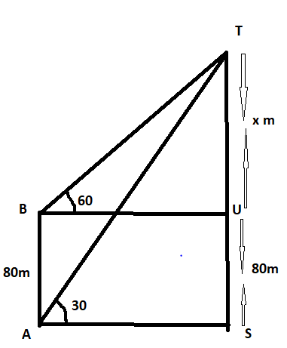200m
2. 400m
3. 432m
4. 500m

**Answer:** B

**Solution:**

According to the question

**Q9.**

**Question Type: MCQ**

**Question Difficulty Level: Medium**

**Marking: (+2, -0.5)**

**Expected time to solve: 30 seconds**

**Topic: Advance Math**

**Concept: mensuration**

**Sub- Concept: circle**

**Concept Field:**

A wooden round table has to be covered with a cover which has six equal designs as shown in fig. if the radius of the cover is 42cm. find how much money he spend on making this cover design at the rate of Rs.4.50 per cm2?

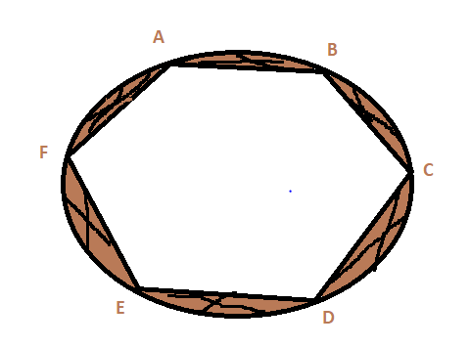

1. 70֯
2. 80֯

AYour text here

1. 110֯
2. ֯

Answer: D

Solution:

It is known that the designs of the cover form six segments of a circle of radius 42cm ain which each angle is 60o.

Area of six design of cover

=6×

Where r=42cm and

Take the value of as 1.73 then,

Now the cost of design of cover at the rate of Rs.4.50

**Q10.**

**Question Type: MCQ**

**Question Difficulty Level: Medium**

**Marking: (+2, -0.5)**

**Expected time to solve: 30 seconds**

**Topic: Advance Math**

**Concept: Geometry**

**Sub- Concept: circle**

**Concept Field:**

In a circle AB is a chord of length 48cm and radius of circle given is 25cm. the tangent at A and B intersect at a point S. find the length of SA?

1. 150.85 cm3
2. 201.23 cm3
3. 345 cm3
4. 134.211 cm3

Answer: a

Solution:

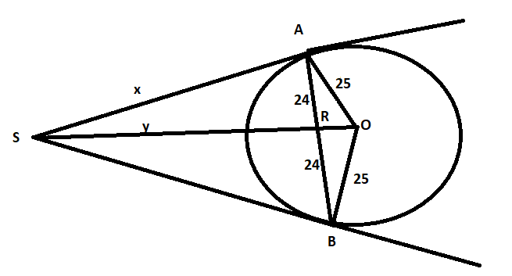

Let SR=y and the center of the circle be O

AR=RB=24cm

From the figure in right angled triangle ORA

Now in right angled triangle ARS and OAS, we have

Put value of SR in eq. 1

Length of SA is 600/7 cm.

**Q11.**

**Question Type: MCQ**

**Question Difficulty Level: Medium**

**Marking: (+2, -0.5)**

**Expected time to solve: 30 seconds**

**Topic: Basic Math**

**Concept: Time and work**

**Sub- Concept: concept of efficiency**

**Concept Field:**

If A can complete 1/9 part of the work in 5 days and B can complete the part of same work in 10 days. A and B starting the work on alternate days. Then on which date they will complete the work if A starts the work from 2nd of March?

1. 44th march
2. 9th may
3. 10th April
4. 23th March

**Answer:** C

**Solution:**

A does work in 5 days so, 1 work = 9 5 = 45 days

B does work in 10 days so, 1 work = 10 = 36 days

Total work = LCM of 45,36= 180 unit

A’s 1 day work = = 4 units

B’s 1 day work = = 5 units

Since, A starts the work on 1st day= 4 units and B starts the work on 2nd days= 5 units

Total work done by A and B in 2 days= 4 + 5= 9 units

So, time taken to complete 180 units of work = × 2= 40 days

The works starts on 2nd of march so the work will be completed on 10th april.

**Q12.**

**Question Type: MCQ**

**Question Difficulty Level: Medium**

**Marking: (+2, -0.5)**

**Expected time to solve: 30 seconds**

**Topic: Basic Math**

**Concept: Speed, time and distance**

**Sub- Concept: concept based on trains**

**Concept Field:**

A train have to travel 600 km to reach the destination. But due to problem in engine speed of train slowed down thus average speed reduced by 20 kmph and the time of journey increased by 5 hours. Then actual speed of the train is

1. 60km/hr
2. 24km/hr
3. 43km/hr
4. 67km/hr

**Answer:** A

**Solution:**

Let the actual speed of the train be x kmph

According to the question,

= 5

= 5

= 5

= 1

x² -20x -2400 = 0

x² - 60x + 40x – 2400 = 0

x(x – 60) + 40(x – 60) = 0

(x + 40) = 0 and x – 60 = 0

x = 60 kmph neglect, x = -40 kmph

Therefore, required speed = 60 kmph.

**Q13.**

**Question Type: MCQ**

**Question Difficulty Level: Medium**

**Marking: (+2, -0.5)**

**Expected time to solve: 30 seconds**

**Topic: Basic Math**

**Concept: Algebra**

**Sub- Concept: basic identities**

**Concept Field:**

If , then the value of is

1. 5
2. 3
3. 1
4. 4

**Answer:** D

**Solution:**



**Q14.**

**Question Type: MCQ**

**Question Difficulty Level: Medium**

**Marking: (+2, -0.5)**

**Expected time to solve: 30 seconds**

**Topic: Basic Math**

**Concept: Simplification**

**Sub- Concept: partnership**

**Concept Field: Operation or decimal fraction**

If 3x- 7y= 14 and  , then what is the value of xy?

1. 13
2. 56
3. 23
4. 12

**Answer: d**

**Solution:**

According to the question,

9x = 7x + 7y

2x = 7y -----1

Now,

3x – 7y = 14

3x – 2x = 14

x = 14

x = 14

Put x = 14 in equation 1 then,

2

y = 4

xy = 14 = 56.

**Q15.**

**Question Type: MCQ**

**Question Difficulty Level: Medium**

**Marking: (+2, -0.5)**

**Expected time to solve: 30 seconds**

**Topic: Basic Math**

**Concept: percentage**

**Sub- Concept: concept of percentage**

**Concept Field:**

In an examination paper of five questions, 8 % of the candidates answered all of them and 8% answered none. Out Of the rest, 25% candidates answered only one question and 20% answered 4 questions. If 462 candidates answered either 2 questions or 3 questions, the number of candidates that appeared for the examination was

1. 1200
2. 1500
3. 2300
4. 3220

**Answer: b**

**Solution:**

8% answered all and 8% answered none

Remaining = (100 – 16)% = 84%

Percentage of candidates answered only one question =

Percentage of candidates answered only four question =

Total = (16+21+16.8) = 53.8%

Percentage of candidates answered either 2 questions or 3 questions = (100-53.8)% = 46.2%

Given, Number of candidates answered either 2 questions or 3 questions = 693

So, 46.2% = 693

100% =

So, 1500 candidates were appeared in the examination.

**Q16.**

**Question Type: MCQ**

**Question Difficulty Level: Medium**

**Marking: (+2, -0.5)**

**Expected time to solve: 30 seconds**

**Topic: Advance Math**

**Concept: Mensuration**

**Sub- Concept: frustum**

**Concept Field: Volume**

The perimeter of the ends of a frustum are 84cm and 32cm. if the height of the frustum is 18cm. find the volume of the frustum?

**Answer:** A

**Solution:**

Let R1 and R2 be the radius of the circular ends of the frustum and H be the height of frustum. Then,

Let V is the volume of frustum of a cone. Then,

Volume

**Q17.**

**Question Type: MCQ**

**Question Difficulty Level: Medium**

**Marking: (+2, -0.5)**

**Expected time to solve: 30 seconds**

**Topic: Basic Math**

**Concept: Percentage**

**Sub- Concept: concept of percentage**

**Concept Field: Important formula**

Due to economic slowdown in the economy from the impact of Covid-19 there is reduction of 33.33% in the price of salt makes a person to buy 6 kg more salt for Rs 648. Calculate the original price of salt.

1. Rs.23
2. Rs.15
3. Rs.14
4. Rs.36

**Answer:** D

**Solution:**

Let he initially bought 90 kg salt in Rs 90

After reduction of 33.33% new rate = 90 - 90 = Rs 60

Now in Rs 60 he bought 90 kg

So, in Rs 90 he will buy = 90 = 135 kg

Increased quantity in salt = 135 – 90 = 45 kg

Now,

He bought 45 kg more sugar when original weight of salt = 90 kg

So, 6 kg more salt he will bought when original weight = = 12 kg

So, total weight of salt after reduction = 6+12 = 18 kg

Therefore, original price of salt per kg == Rs 36/kg

**Q18.**

**Question Type: MCQ**

**Question Difficulty Level: Medium**

**Marking: (+2, -0.5)**

**Expected time to solve: 30 seconds**

**Topic: Basic Math**

**Concept: Simplification**

**Sub- Concept: operation of decimal fraction**

**Concept Field: addition and subtraction of decimal fraction**

If the numerator of a fraction is decreased by 50% and the denominator of the fraction is increased by 400% then the resultant fraction is. Find the original fraction.

1. 2/3
2. 9/5
3. 8/3
4. 2/3

**Answer:** d

**Solution:**

Let the original fraction be .

According to question,

The numerator is decreased by 50% =(x-50%)ofx

The denominator is increased by 400% =(y+400%)ofx

=

= =

So, the resultant fraction is

**Q19.**

**Question Type: MCQ**

**Question Difficulty Level: Medium**

**Marking: (+2, -0.5)**

**Expected time to solve: 30 seconds**

**Topic: Basic Math**

**Concept: Time, speed and distance**

**Sub- Concept: boat and stream**

**Concept Field:**

Himalaya can row her boat at a speed of 6km/hr in still water. If the time taken by Himalaya to row the boat upstream 9 km is 2 hr more than to return downstream. Find the speed of the stream?

1. 3km/hr
2. 2km/hr
3. 4km/hr
4. 7km/hr

**Answer:** A

**Solution:**

Let the speed of the stream be x km/hr

Speed of boat upstreamkm/hr

Speed of boat downstreamkm/hr

Time taken for going upstream hrs

Time taken for going downstream 9 hrs

We know that the time taken by upstream is more than that of time taken downstream

It is given that time taken for going 9 km upstream is 2 hr more than the time taken for going

9km downstream.

So, the speed of stream is 3 km/hr.

**Q20.**

**Question Type: MCQ**

**Question Difficulty Level: Medium**

**Marking: (+2, -0.5)**

**Expected time to solve: 30 seconds**

**Topic: Basic Math**

**Concept: Age related problems**

**Sub- Concept: age related problems**

**Concept Field:**

The product of shyam age 8 year ago with his age 8 year later is 10. Calculate the present age of Shyam?

1. 2 yr
2. 14 yr
3. 15 yr
4. 9 yr

**Answer:** D

**Solution:**

Let Shyam present age be x yrs. Then,

Shyam age 8 years ago=x-8

Shyam age 8 year later=x+10

It is given that the product of these ages is 19.

Hence, Shyam present age is 9 years

**Q21.**

**Question Type: MCQ**

**Question Difficulty Level: Medium**

**Marking: (+2, -0.5)**

**Expected time to solve: 30 seconds**

**Topic: Data interpretation**

**Concept: line graph**

**Sub- Concept: Line graph**

**Concept Field: Percentage**

Given below is a line chart which shows the number of students in 5 different collages A, B, C, D and E and they all have different hobbies likes singing, playing and dancing.

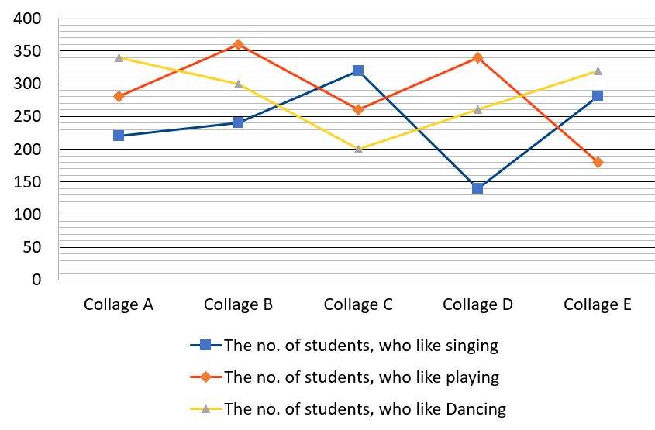

If in collage C, 35% students are girls and the total number of girls in collage C, who likes singing and playing, is 190, then what is the percentage of girls, who like dancing?

1. 41.5%
2. 35.5%
3. 39.5%
4. 44.5%

**Answer: A**

**Solution:**

**Q22.**

**Question Type: MCQ**

**Question Difficulty Level: Medium**

**Marking: (+2, -0.5)**

**Expected time to solve: 30 seconds**

**Topic: Data interpretation**

**Concept: line graph**

**Sub- Concept: Line graph**

**Concept Field: ratio**

Given below is a line chart which shows the number of students in 5 different collages A, B, C, D and E and they all have different hobbies likes singing, playing and dancing.



What is the ratio between the number of students, who like Singing and the number of students, who like playing in all the collages together?

1. 17:12
2. 60:71
3. 13:31
4. 19:63

**Answer: B**

**Solution:**

The number of students, who like Singing in all the collages together

The number of students, who like playing in all the collages together

Required ratio of number of student, who like singing and who like playing= 1200: 1420 = 60: 71

**Q23.**

**Question Type: MCQ**

**Question Difficulty Level: Medium**

**Marking: (+2, -0.5)**

**Expected time to solve: 30 seconds**

**Topic: Data interpretation**

**Concept: line graph**

**Sub- Concept: Line graph**

**Concept Field: percentage**

Given below is a line chart which shows the number of students in 5 different collages A, B, C, D and E and they all have different hobbies likes singing, playing and dancing.



The number of students, who like dancing in all the collages together, is what per cent of the number of students, who like playing in all the collages together?

1. 100%
2. 231%
3. 244%
4. 321%

**Answer: A**

**Solution:**

The number of students, who like dancing in all the collages together

The number of students, who like playing in all the collages together

Required percentage

**Q24.**

**Question Type: MCQ**

**Question Difficulty Level: Medium**

**Marking: (+2, -0.5)**

**Expected time to solve: 30 seconds**

**Topic: Data interpretation**

**Concept: line graph**

**Sub- Concept: Line graph**

**Concept Field: Average**

Given below is a line chart which shows the number of students in 5 different collages A, B, C, D and E and they all have different hobbies likes singing, playing and dancing.



Find the average of the total number of students of all the collages together, who like dancing?

1. 342
2. 123
3. 284
4. 536

**Answer: C**

**Solution:**

The number of students of all the collages together, who like dancing

Required average

**Q25.**

**Question Type: MCQ**

**Question Difficulty Level: Medium**

**Marking: (+2, -0.5)**

**Expected time to solve: 30 seconds**

**Topic: Data interpretation**

**Concept: line graph**

**Sub- Concept: Line graph**

**Concept Field: Average**

Given below is a line chart which shows the number of students in 5 different collages A, B, C, D and E and they all have different hobbies likes singing, playing and dancing.



The total number of girls who like singing in all the collage together is 40%, then find the difference between the average of number of boys to that of girls in all the collages together who like singing?

1. 42
2. 64
3. 23
4. 48

**Answer:** D

**Solution:**

The total number of students, who like singing in all the collages together

The number of girls, who like singing in all the collages together

The number of boys, who like singing in all the collages together

Required difference between the average no. of boys to that of girls who like singing